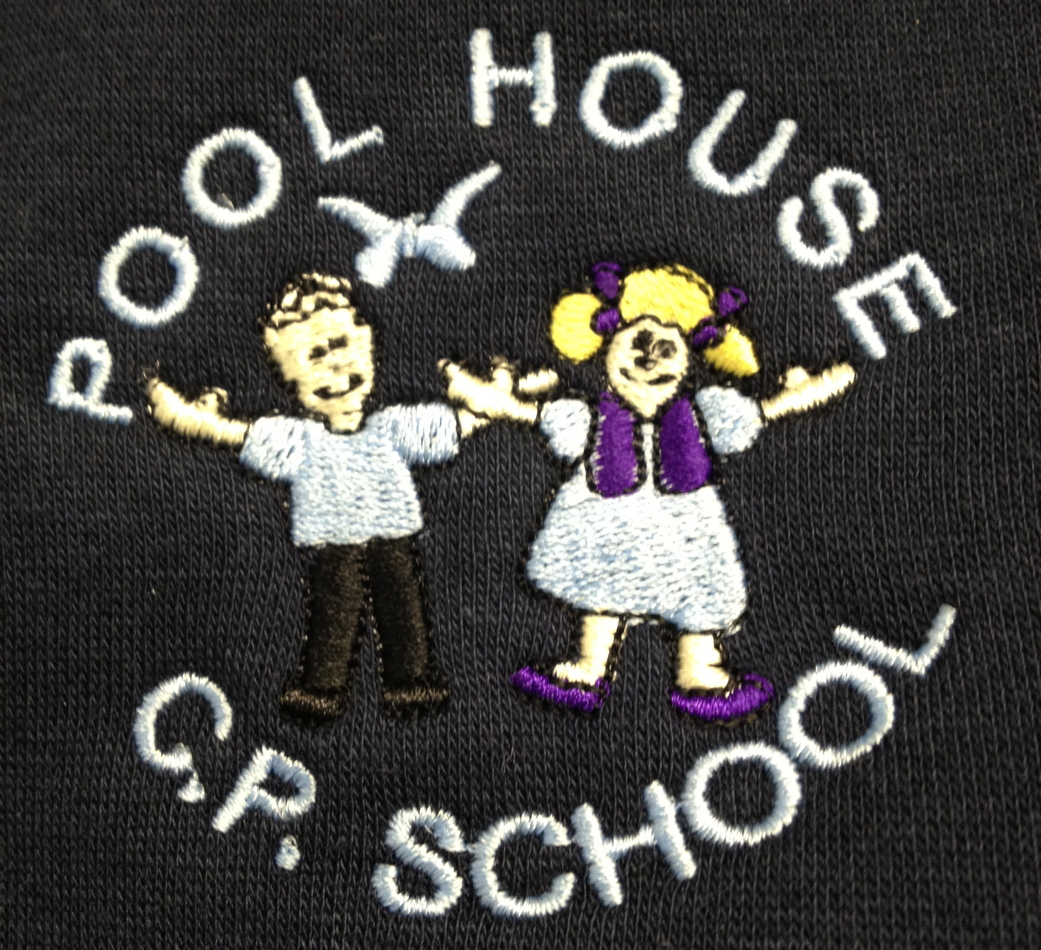 Pool House CP School

Reporting to Parents Policy

School Profile

In accordance with legal requirements Governors at Pool House will ensure that the school has a published Website. The School Website will be updated continually to ensure information is up to date and accurate.

Reporting Pupil’s Progression and Development

Each Summer term a written report will be forwarded to the parent/guardian of every child on the school roll. Shortly afterwards there will be an opportunity for the parent/guardian to discuss this report with the class teacher and/or the headteacher if necessary.

Formal parents evenings will also be held during the Autumn and Spring terms.

Pool House operates an ‘open door’ policy enabling a parent/ guardian to request a discussion on their child’s progress at a mutually convenient time at any point during the school year.

January 2017

