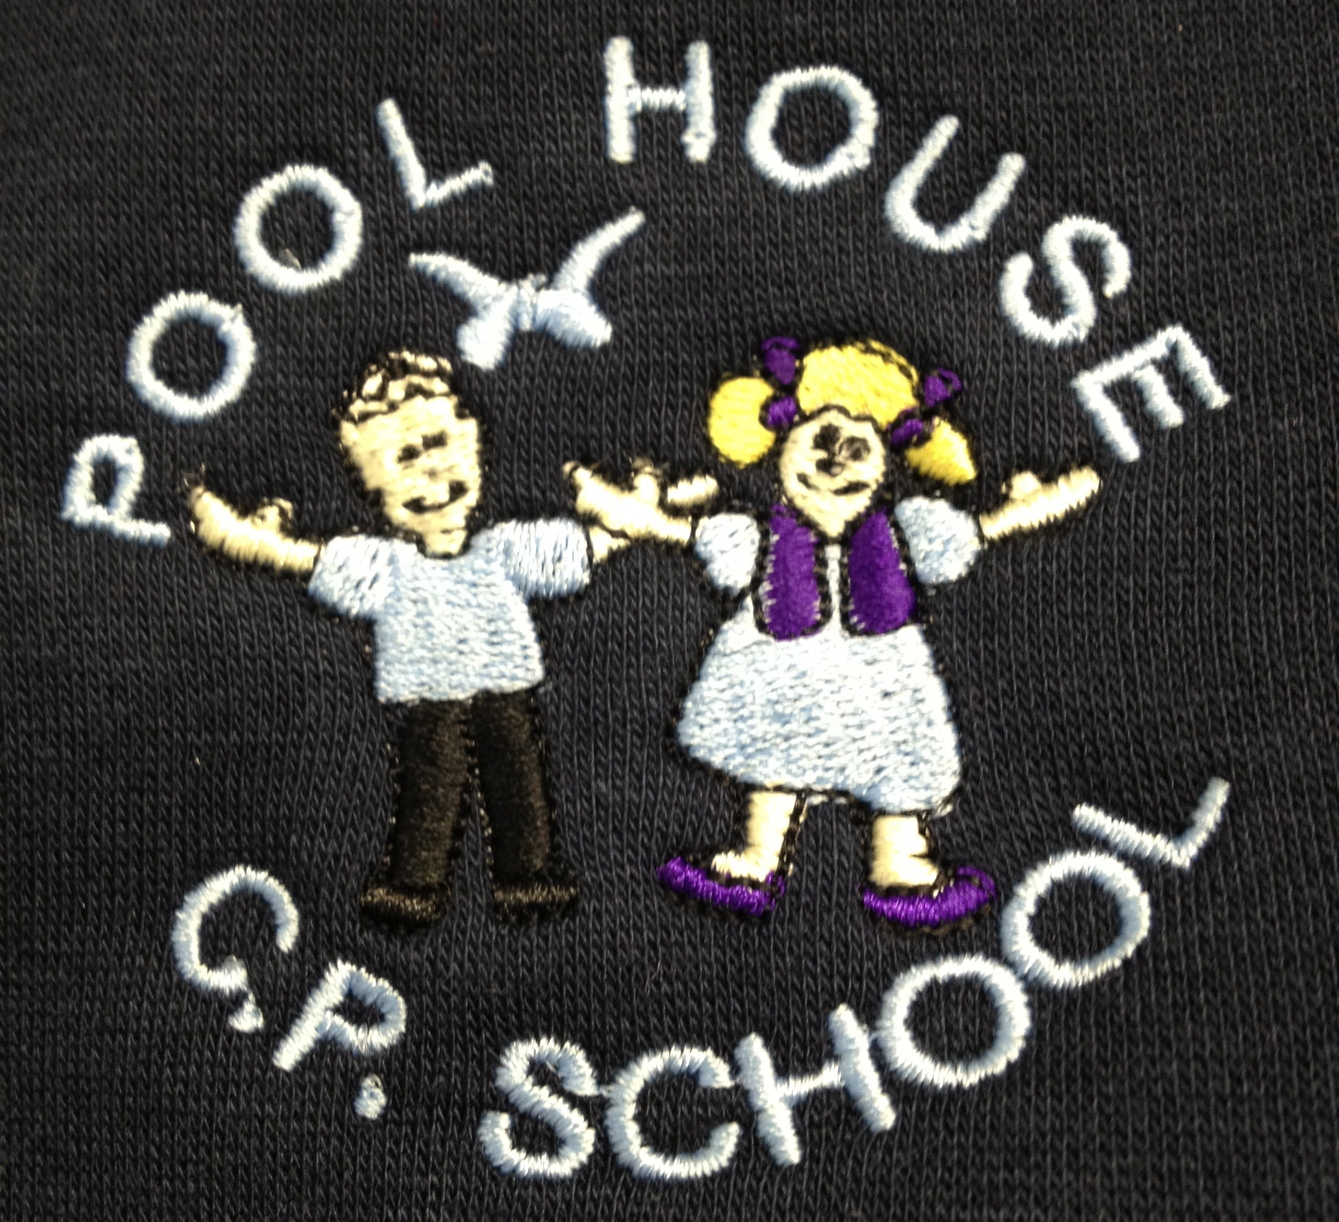 Pool House C P School
Equality and Diversity Policy

Statement of Intent

Pool House Community Primary School is committed to providing equality of opportunity and anti-discriminatory practice for all children and families.

Aim
We aim to:
*provide a secure environment in which all our children can
flourish and in which all contributions are valued;
*include and value the contribution of all families to our
understanding of equality and diversity;
*provide positive non-stereotyping information about different
ethnic groups and people with disabilities;
*improve our knowledge and understanding of issues of equality
and diversity;
*make inclusion a thread which runs through all of the activities
of the school.

The legal framework for this policy is:
Race Relations Act 1976;
Race Relations Amendment Act 2000;
Sex Discrimination Act 1986;
Children Act 1989; and
Special Educational Needs and Disability Act 2001.

Procedures

Admissions
Our school follows Local Authority admission guidelines and works to our own published admissions policy which is available on request. All children in the local community are eligible for admission into school. We base our admissions policy on a fair system. We do not discriminate against a child with a disability or refuse a child entry to our school because of any disability.

We make every effort to reflect the diversity of members of our society in our publicity and promotional materials.
We provide information in clear, concise language, whether in spoken or written form. We provide information in English as there are currently no other languages spoken as a first language at home.

We ensure that all parents are made aware of our equal opportunities policy.

We develop an action plan to ensure that people with disabilities can participate successfully in the services offered by the school and in the curriculum offered.

Vacant Posts
Posts are advertised and all applicants are judged against explicit and fair criteria. The applicant who best meets the criteria is offered the post, subject to references and checks by the Criminal Records Bureau. This ensures fairness in the selection process. All job descriptions include a commitment to equality and diversity as part of their specifications. We monitor our application process to ensure that it is fair and accessible.

Training
We seek out training opportunities for staff and volunteers to enable them to develop practices which enable all children to flourish.
We review our practices to ensure that we are fully implementing our policy for equality and diversity.

Curriculum
The curriculum offered in the school encourages children to develop positive attitudes to people who are different from themselves. It encourages children to empathise with others and to begin to develop the skills of critical thinking.

We do this by:
making children feel valued and good about themselves;
ensuring that children have equality of access to learning;
reflecting the widest possible range of communities in the choice of resources;
avoiding stereotypes or derogatory images in the selection of materials;
celebrating a wide range of festivals;
creating an environment of mutual respect and tolerance;
helping children to understand that discriminatory behaviour and remarks are unacceptable;
ensuring that the curriculum offered is inclusive of children with special educational needs and children with disabilities; and
ensuring that children whose first language is not English have full access to the curriculum and are supported in their learning.

Valuing Diversity in Families
We welcome the diversity of family life and work with all families.
We encourage children to contribute stories of their everyday life into school.
We encourage parents/carers to take part in the life of the school and to contribute fully.
For families who have a first language other than English, we value the contribution their culture and language offer.
We offer a flexible payment system for families of differing means in relation to trips, school visits etc.

Food
We work in partnership with parents to ensure that the medical, cultural and dietary needs of children are met.
We help children to learn about a range of food, cultural approaches to mealtimes and eating and to respect the differences among them.

.
January 2017

